**Department of Systemics**

**School of Computer Science**

University of Petroleum and Energy Studies

cid:image003.png@01D81F60.F8BDA810

**ADVANCE DATABASE MANAGEMENT SYSTEM**

**LAB FILE**

Submitted by

**Akshat Negi**

**R2142220414**

**Batch - 2**

B.Tech Computer Science and Engineering(CSF)

Submitted to

**Dr. KOTHA VENUGOPALCHARY**

Assistant Professor (SS)

SOCS, UPES

**LAB EXPERIMENT – 6**

Created table of table name: EMPLOYEES and added 6 rows:

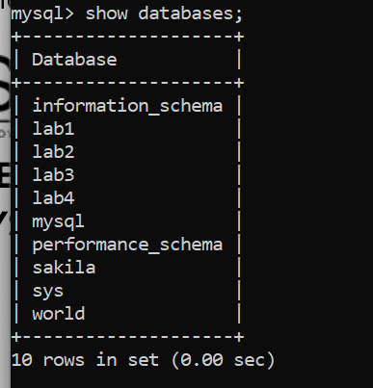



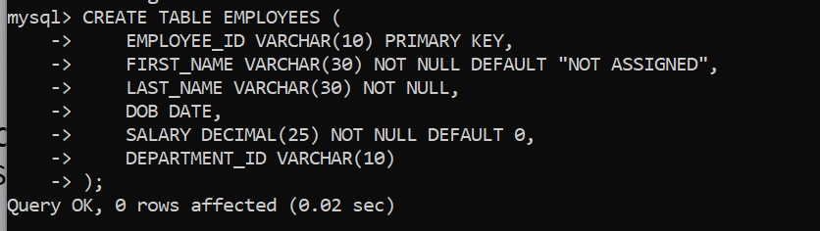

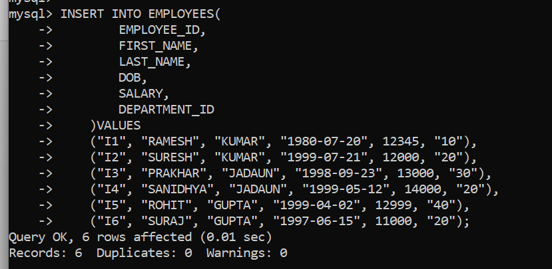

**2. Execute the following view related queries:**

**1) Create View of name emp_view and the column would be Employee_id, Last_Name, salary and department_id only.:**

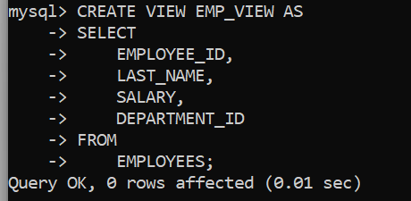

**2) Insert values into view(remove the NOT NULL constraint and then insert values):**

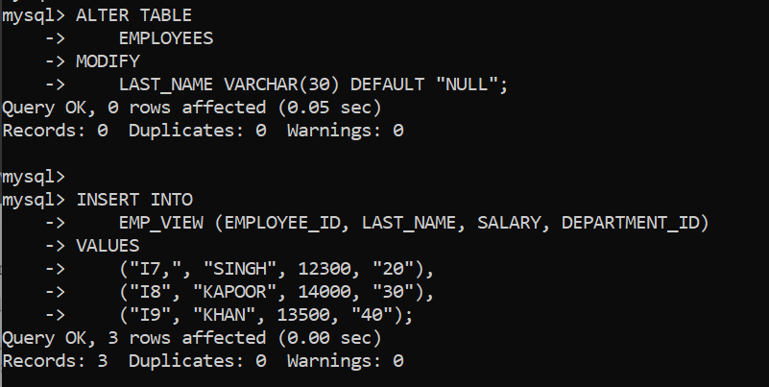

**3) Modify, delete and drop operations are performed on view.:**

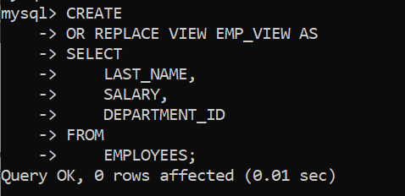

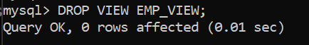

**4) Creates a view named salary_view. The view shows the employees in department 20 and their annual salary.**

